God cares for people and possessions
Nehemiah 7

Introduction
Today’s Plan Summary review of the chapter, highlighting several key points
Finishing with a message that is relevant to every person
One of Satan's greatest psychological weapons is a gut-level feeling of inferiority, inadequacy, and low self-worth. Low self-esteem paralyzes our potential, destroys our dreams, ruins our relationships, and sabotages our Christian service.
Deep Wounds Deep Healing: Discovering the Vital Link between Spiritual Warfare and Inner Healing by Charles Kraft
SLIDE 2
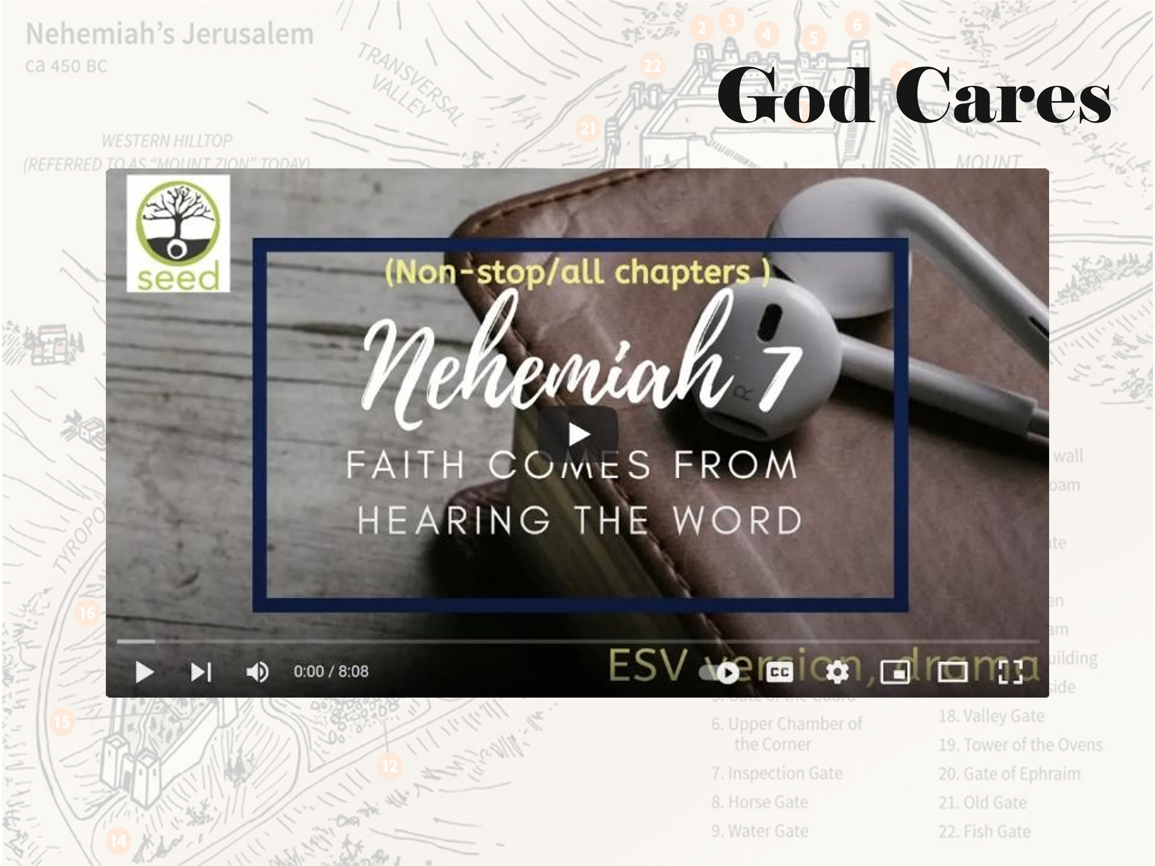

LISTEN AND PRAY https://www.youtube.com/watch?v=YSjCfPA62-Y
Review In the face of opposition, God’s hand was on N and the people
A unified team can see supernatural results
Ex: Wall done in 52 days (6:15) vs 141 years
Do we make excuses to explain away the problems or make plans to make them better
SLIDE 3
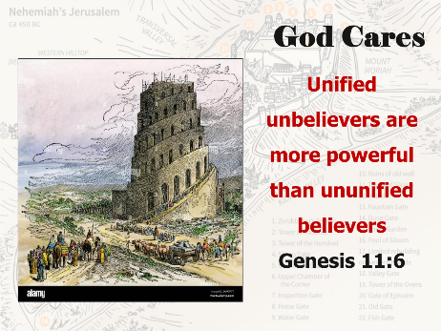
Interest Remember the tower of Babel
READ Gen 11:6
Unified unbelievers are stronger than divided believers

SLIDE 4
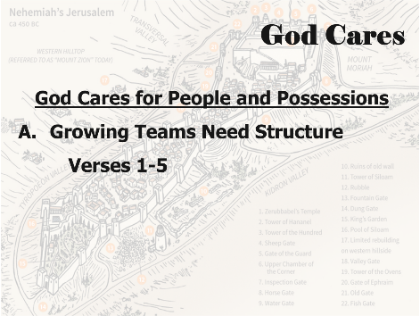
Sermon Theme God cares for people and possessions

Division 1 Growing teams need structure V 1-5

Explanation N started putting things in place for his return to Susha (2:6)
Gatekeepers, singers, Levites
V 2 His leaders were faithful and God-fearing
Illustration Faithful and God-fearing
SLIDE 5

Knowledge, beliefs, actions
Faithful ministry occurs when we close the gap between what we believe and how we actually live and minister. That discrepancy is our growth potential.
SLIDE 6
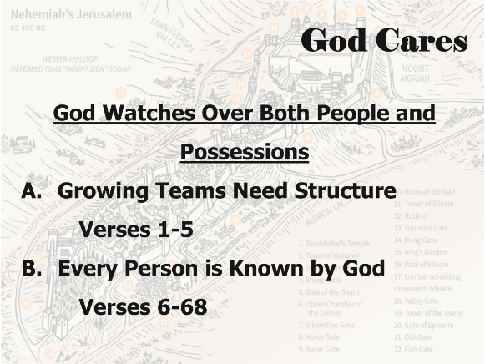
Argumentation The trio of evil was still around, so there needed to be gates and people at the wall
Application V 5 “God put it in my heart.”
What has God put into your heart?
Ask Him direct questions until you have an answer
Are you doing it?
Many miss their opportunity because they don’t ask, or say no to His answer

Transition God cares for people and possessions
SLIDE 6b
Division 2 Every person is known by God V 6-68

Explanation List is similar to Ezra 2
42,360 people (Neh 7:66 and Ezra 2:64)
Argumentation God as a steward of people and things
Servants and animals are listed – they are important too
Illustration Luke 15 – Lost sheep, Lost coin, Lost Son
Application How are we doing in our stewardship?
Not only a money topic
Transition God cares for people and possessions

SLIDE 7
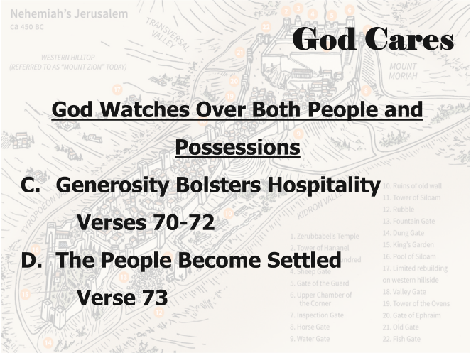

Division 3 Generosity bolsters hospitality V 70-72

Explanation The church is the only place on earth that is free.

Because the people give
Governor is N and he gave – 2%
House leaders gave – 48%
People gave – 48%
Illustration We give our time, talent, and money as an act of generosity
Argumentation God gives and forgives
Application And He forgets our sins - Ps 103:12
As far as the east is from the west, so far has He removed our transgressions from us.
Based on this truth, we can’t stand idly by

Transition God cares for people and possessions

SLIDE 7b
Division 4 The people become settled V 73

Explanation Wall finished at the end of the 6th month, in the seventh month, they are settled

The year is 444 BC
Argumentation The building work wasn’t all that important; what was important was the benefit the building gave to God’s people. The building work taught them to work hard, to work together, to work through adversity and attack, and to work till the wall was done.

SLIDE 8
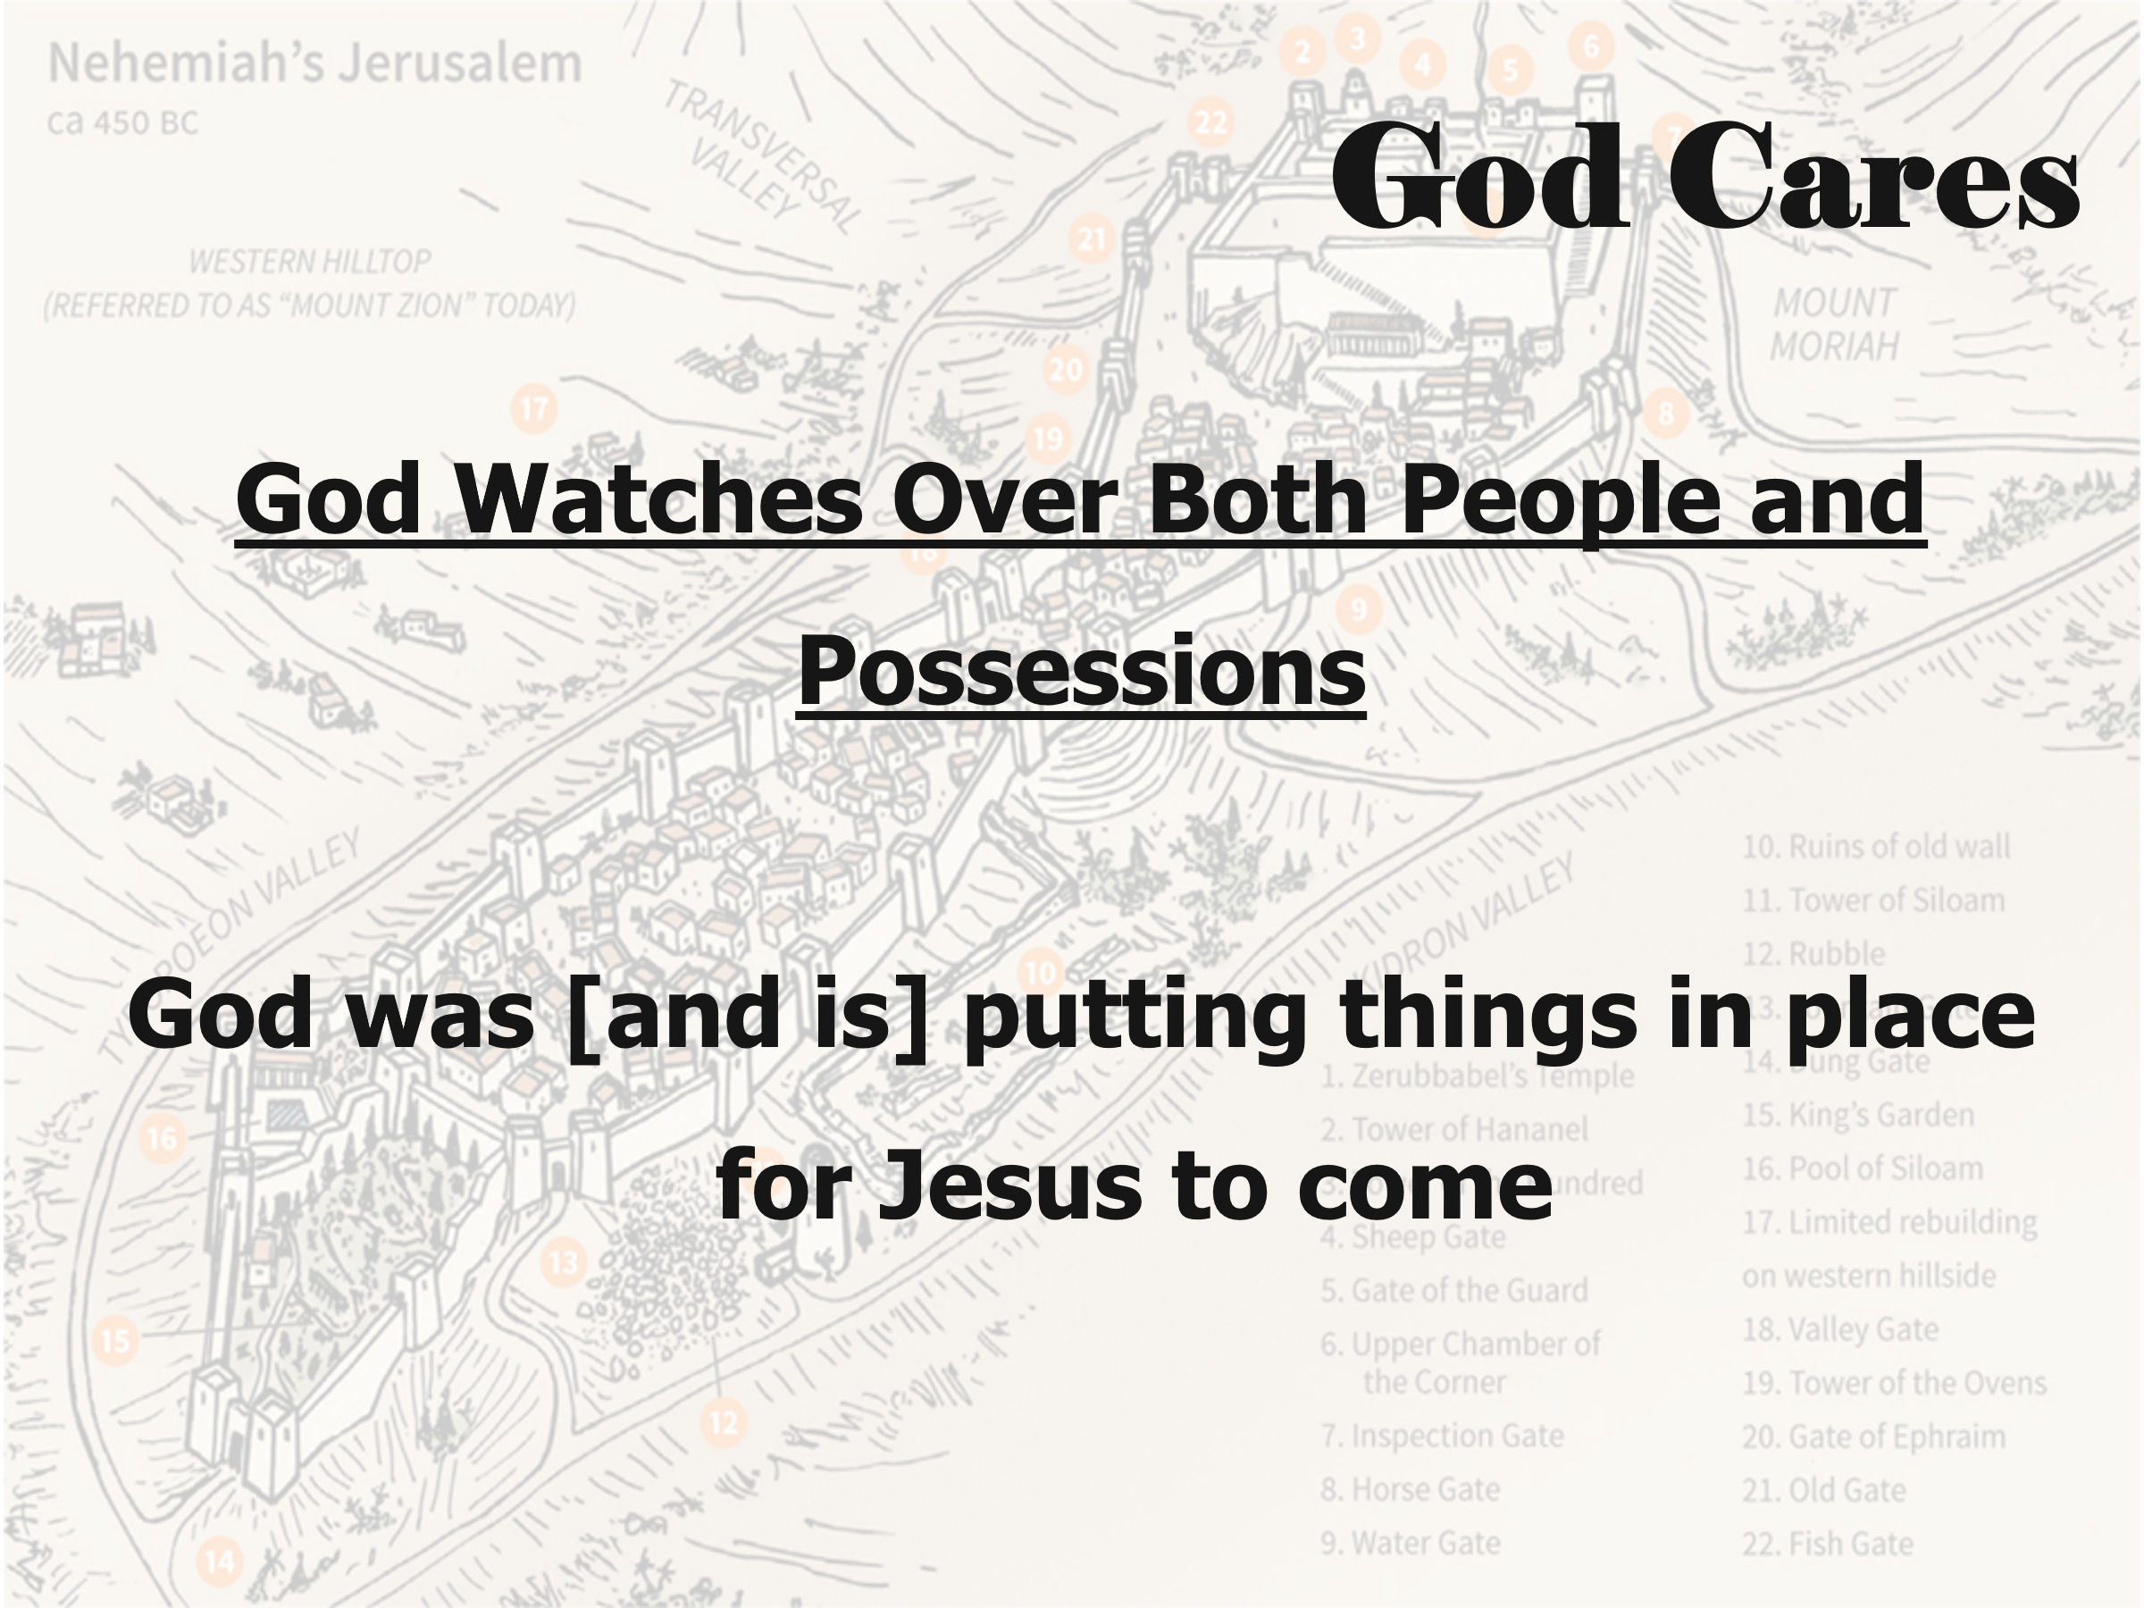
Conclusion
The world is divided and needs a united church
Visualization By rebuilding the temple and the wall, God is getting ready to send His Son
God is always at work, fulfilling His plans
SLIDE 9
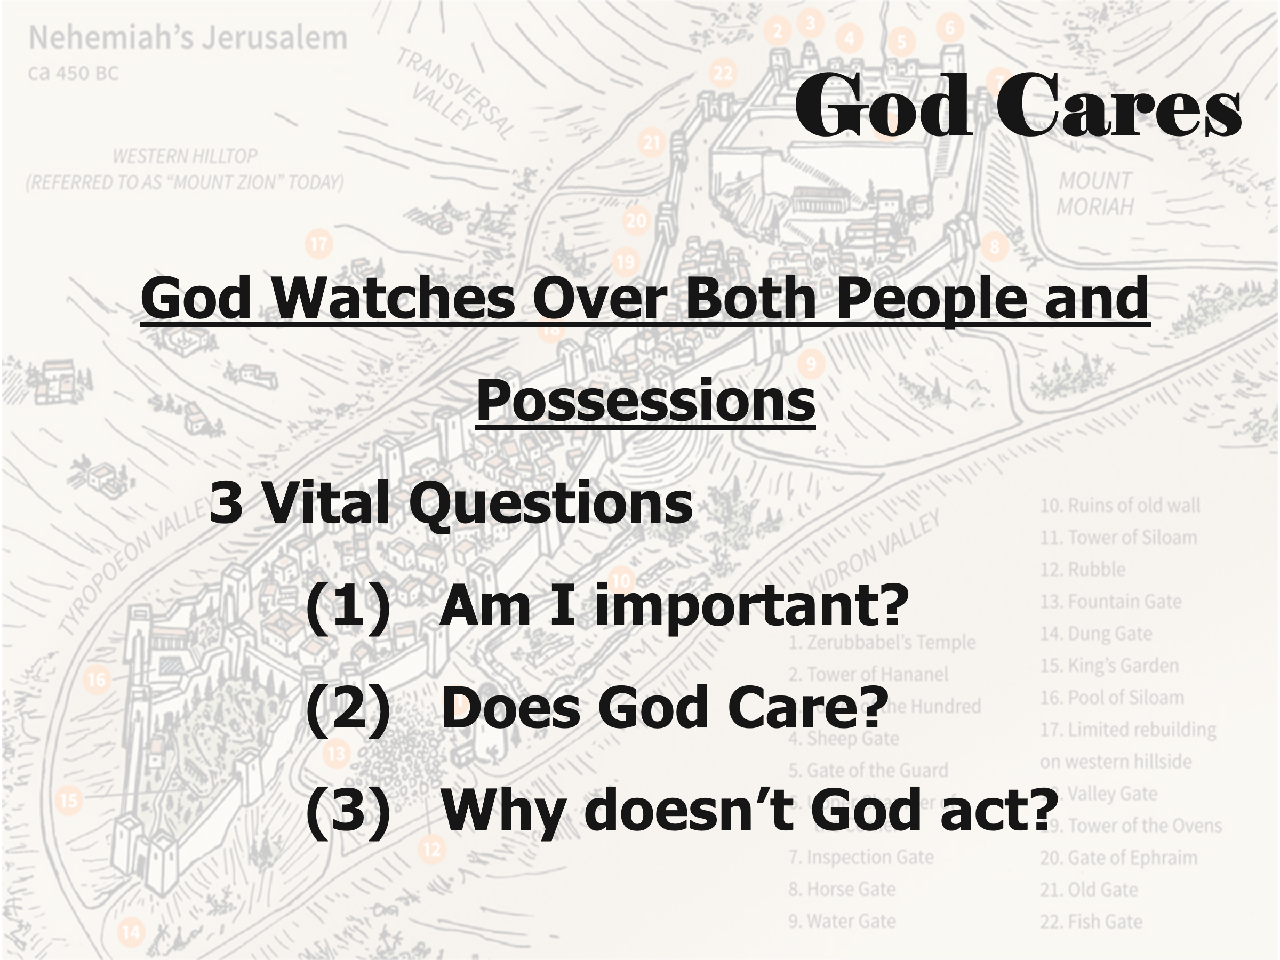
Appeal 3 Vital Questions
(1) Am I important?
(2) Does God Care?
(3) Why doesn’t God act?

(1) Am I important?
The world population is 8.2 billion
About 105 billion people have lived since creation
Ps 8:3-4 – we are very small
ANSWER
Ps 139:1-6 – God knows us
Lists from this chapter
(2) Does God Care?
We don’t know why things happen to our family or us
Job did not know
The world was perfect, and sin brought all our problems
God will restore everything
OT writers asked this question openly
Jesus asked, “Why have You forsaken me?”
ANSWER – God suffers with us
(3) Why doesn’t God act?
Volcanoes, fires, earthquakes, and diseases
Terrorists, war, genocide
ANSWER
He does act, just not always on our terms
Where is your hope and your faith?
Only in physical health and job success – I hope not
SLIDE 10
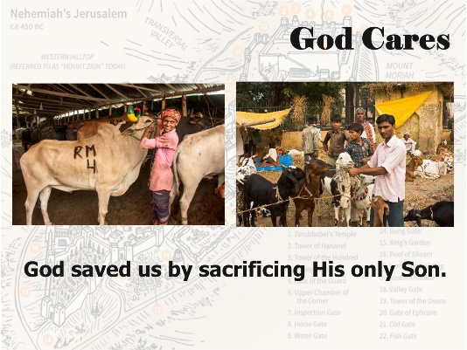
He saved us by sacrificing His only Son
This is Korbani time
SLIDE 11
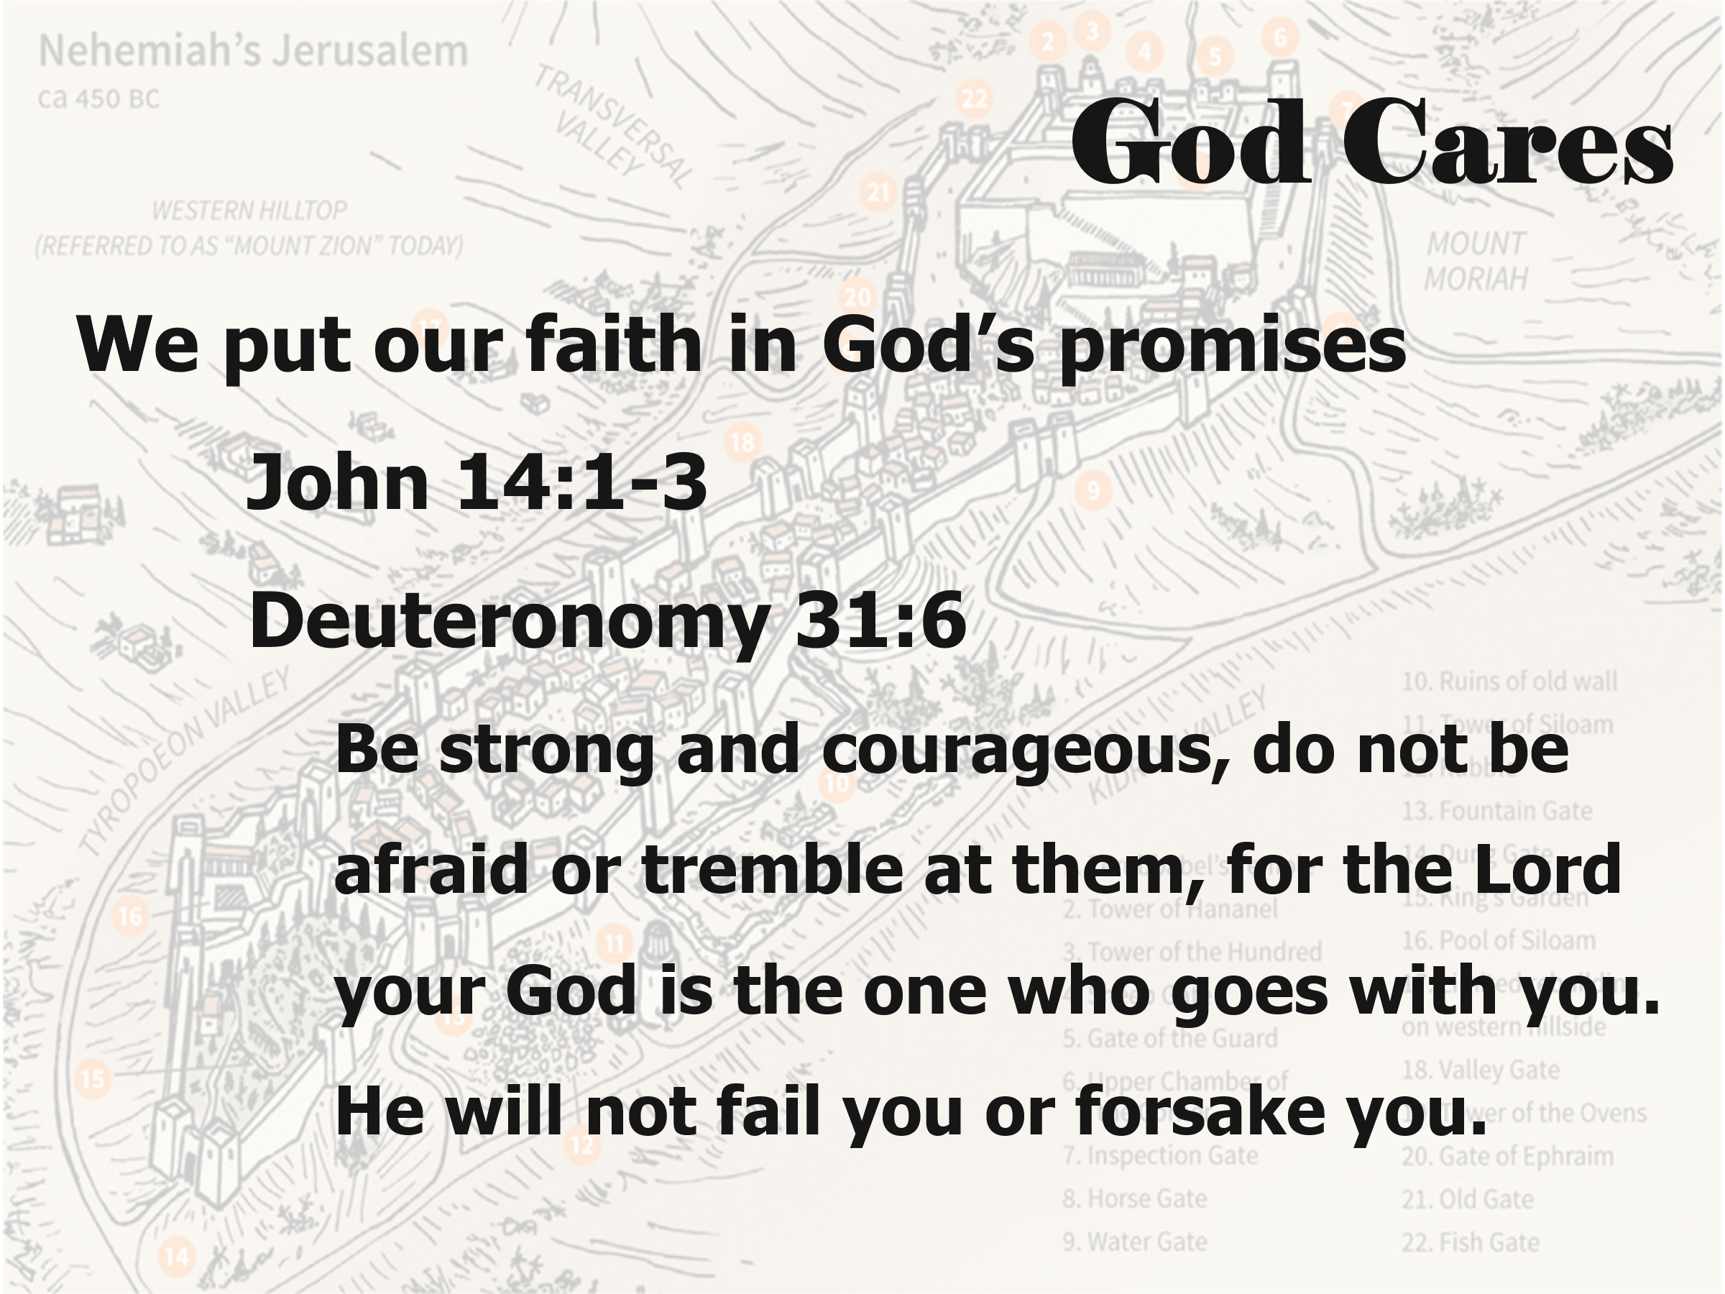

We put our faith in God’s promises
He promised to return for us - Jn 14:1-3
SLIDE 11b
Deut. 31:6
Be strong and courageous, do not be afraid or tremble at them, for the Lord your God is the one who goes with you. He will not fail you or forsake you.”

