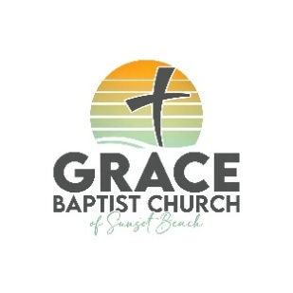 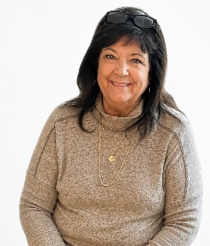 Barbara G Johnston

GRACE BAPTIST CHURCH OF SUNSET BEACH
Barbara G. Johnston Scholarship
Application Form

Overview
- Grace Baptist Church of Sunset Beach (GBC) has been authorized by a gracious donor to distribute designated funds in a manner deemed best by the Pastor and Church Council. These funds are meant for furthering Bible education via either a long-term or short-term course.

- Applications must be submitted before classes begin.
- Application forms must be fully completed before consideration.
- Funds will be reimbursed only after you submit proof of payment for eligible expenses.

CRITERIA
- Students (of any age) who are regular attendees of GBC may apply.
- Students must be enrolled in a Bible-related course, school or conference.
- Reimbursement is available for a one-time course or a series of classes
a. Money may be used for class fees, books, and/or required supplies.

OVERVIEW
- Notification of the GBC's decision will be given within two weeks upon receipt of a completed application.
- Scholarships will not be exceed $1,000 (One thousand dollars). The Pastor and Church Council reserve the right to designate the award amounts.
- It is the applicant’s responsibility to provide itemized and paid receipts matching or exceeding the scholarship amount before reimbursement is processed.
- Once you have completed at least 70% of the course and submitted your paid receipts for approved expenses, the scholarship will be reimbursed to you.
- Scholarship funds will be paid directly to the applicant after receiving and verifying all required paid receipts.
APPLICATION PROCESS

Please email or mail your completed application with all supporting documentation to:
GBC email: gbcsunset17@gmail.com
GBC address: 17 Somerset Road, Pasadena, MD 21122

ALL APPLICANTS MUST INCLUDE:
- Scholarship Application
- Cover Letter, which includes relevant information not included in the scholarship application.
- Copy of Driver’s License or photo identification

For questions or more information, email us at gbcsunset17@gmail.com

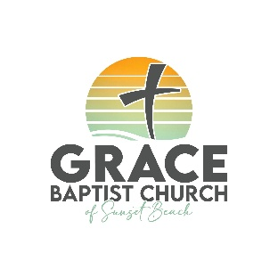
Grace Baptist Church of Sunset Beach
Scholarship Application

Your Name_____________________________________________________

Address________________________________________________________

______________________________________________________________

______________________________________________________________

Phone Number__________________________________________________

Email Address___________________________________________________

Name of School or Program you plan to attend_________________________

______________________________________________________________

Course________________________________________________________

______________________________________________________________

______________________________________________________________

Dates_________________________________________________________

What makes this course or class important to you?

______________________________________________________________

______________________________________________________________

______________________________________________________________

______________________________________________________________

______________________________________________________________

______________________________________________________________

Expected results of taking this course_________________________________

______________________________________________________________

______________________________________________________________

______________________________________________________________

______________________________________________________________

______________________________________________________________

______________________________________________________________

______________________________________________________________

____________________________

______________________________________________________________
Signature Printed Name Date

